Java 8 Practice Interview Questions

Question Related to Stream API

- Refer the following Data module and implement the following assignments using Stream API
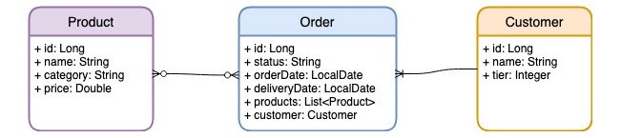

- Exercise 1 — Obtain a list of products belongs to category “Books” with price > 100
- Exercise 2 — Obtain a list of order with products belong to category “Baby”
- Exercise 3 — Obtain a list of product with category = “Toys” and then apply 10% discount
- Exercise 4 — Obtain a list of products ordered by customer of tier 2 between 01-Feb-2021 and 01-Apr-2021
- Exercise 5 — Get the cheapest products of “Books” category
- Exercise 6 — Get the 3 most recent placed order
- Exercise 7 — Get a list of orders which were ordered on 15-Mar-2021, log the order records to the console and then return its product list
- Exercise 8 — Calculate total lump sum of all orders placed in Feb 2021
- Exercise 9 — Calculate order average payment placed on 14-Mar-2021
- Exercise 10 — Obtain a collection of statistic figures (i.e. sum, average, max, min, count) for all products of category “Books”
- Exercise 11 — Obtain a data map with order id and order’s product count
- Exercise 12 — Produce a data map with order records grouped by customer
- Exercise 13 — Produce a data map with order record and product total sum
- Exercise 14 — Obtain a data map with list of product name by category
-Exercise 15 — Get the most expensive product by category

Lambda Expression & Function Interface and Method Reference Use these things where it fits

1.Write a method that returns the index of the first occurrence of given integer in a list.
Assume that the index of the first element in the list is zero.
If the number does not exist return -1.(Linear Search)

2.Write a method that reverses a string.
For example, 'java interview' becomes 'weivretni avaj'.

3.Write a method that returns the largest integer in the list.
You can assume that the list has at least one element.

4.Write a method that returns the average of a list of integers.(Using Lambda Expression)

5.Write a method that converts all strings in a list to their upper case.

6.Given a list of strings, write a method that returns a list of all strings that start with the letter 'a' (lower case) and have exactly 3 letters. TIP: Use Java 8 Lambdas and Streams API's.

(Java 8 Lambdas and Streams)
7. Write a method that returns a comma-separated string based on a given list of integers. Each element should be preceded by the letter 'e' if the number is even, and preceded by the letter 'o' if the number is odd. For example, if the input list is (3,44), the output should be 'o3,e44'.

(Java 8 Lambdas and Streams)
8. Create a Student Inheritance hierarchy as per the requirement.
Note: Use the Predefined Functional Interface like while sorting the List.

a. Get student with exact match name "jayesh"
b. Get student with matching address "1235"
c .Get all student having mobile numbers 3333.
d. Get all student having mobile number 1233 and 1234
e. Create a List<Student> from the List<TempStudent>
f. Convert List<Student> to List<String> of student name
g. Change the case of empName. e.g from Lowecase to Uppercase.
h. Sort List on the basic of empName

9.Create an assignment representing static and default method use.

